**COURSE TITLE: COMPUTER HARDWARE 1**

**COURSE CODE: CTE 115**

**CHAPTER ONE**

**1.0INTRODUCTION**  
Everyday we are challenged with new technology and new adaptations of existing  
technology with the result that we are continually all beginners. While this book is written primarily for people who wish to know more about personal computer (PC) hardware, it may also prove to be helpful to people who wish to expand their knowledge of the PC’s hardware. It is remarkable that a personal digital assistant, such as the Handspring Visor or the Palm Pilot, holds more raw computing power than existed in the entire world only 20 years ago. It is also remarkable that the basic structure of the personal computer over this same 20 years has not changed all that much. The essential components that make a PC are the same today as they were in 1981. What has changed is the integration scale, the ability of the peripherals, and the size and capabilities of the software.I have included all of the technology with which a PC user comes into contact and explain its function and interactions with the other components and technologies in the PC. While the details of all of the PC’s components is included in the book, additional information has been included for the areas to which the beginning user has more contact, such as the audio/visual systems, CD-ROM and DVD drives, hard disk drives, keyboard, mouse, and others.

**1.1The Personal Computer**

Today’s personal computer, like the one shown in Figure 1-1, is a much more powerful computer than the PCs of just five years ago. Not to mention how different the PC is from computers way back in the early days of its development. Remember that the whole of the computer’s history is compacted into a little more than 50 years and the personal computer has only been around for a little over 20 years. In fact, the PC’s most spectacular development has probably been made in just the past five to ten years. It is also safe to say that the computer of today will be nothing compared to what we’ll have in five to ten more years. The one bit of good news in all of this is that the PC will most likely continue to have the same basic hardware components.

* 1. **A BRIEF LOOK AT THE EVOLUTION OF COMPUTERS**  
     Twenty-five years ago, it was virtually unthinkable that somebody would want to have  
     a computer on their desk. Many of the “big” thinkers of the time could not even conceive  
     of what anyone would possibly do with such a thing. It was a time of mainframes and  
     minicomputers, which served the needs of corporations, companies, and departments.  
     The idea that a single person could possibly have use for a computer all to themselves  
     was just unthinkable

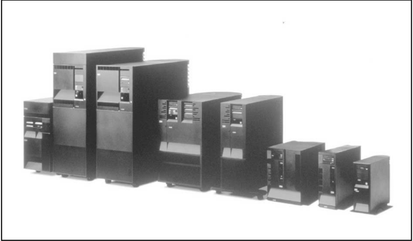

Fig 1.2 personal computers come in different sizes

* 1. **Mainframe Computers**  
     Until the dawn of the personal computer in the early 1980s, computers were large, multiple cabinet affairs that required special room conditions and trained operators and programmers. *Mainframe computers*, the size of the computers can literally fill a room. These large computers, sold by IBM, Amdahl, Unisys, Hitachi, and others, are used to fulfill the computing needs of large companies and corporations and are also used in large telecommunications centers. They are very powerful with huge amounts of storage and processing capability. The drawbacks to the mainframe computer for use as a personal computer are its size, its immense amount of computing power, and its price, which can run into the millions of dollars.

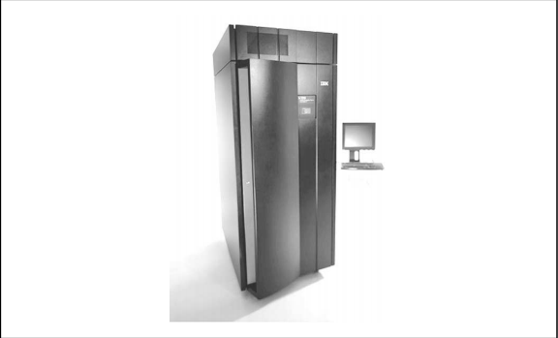

Fig 1.3 mainframe computer

* 1. **Minicomputers**  
     The *minicomputer* was developed to serve the computing needs of smaller companies and the larger departments of corporations. The minicomputer, also known today as a midrange computer, has essentially the same functionality of the larger mainframe computer but on a smaller scale—and not much smaller, at that. The minicomputer was developed largely to open new markets for computers after most of the larger companies had purchased mainframes. The mainframe was scaled into a smaller package with most of its functions remaining and a little less storage and processing power, sold at a reduced price. There are computing devices today, made by Hewlett Packard, Compaq, and others, that are manufactured under the name minicomputer that are in fact midlevel computers that are more powerful than personal computers and less powerful than a mainframe. Because of advances in technology, today’s minicomputer can fulfill the entire computing needs of a small- to medium-sized company as well as serve as a very powerful communications server. Minicomputers are much too big, in terms of processing power and size, not to mention price, to be used as a personal computer.

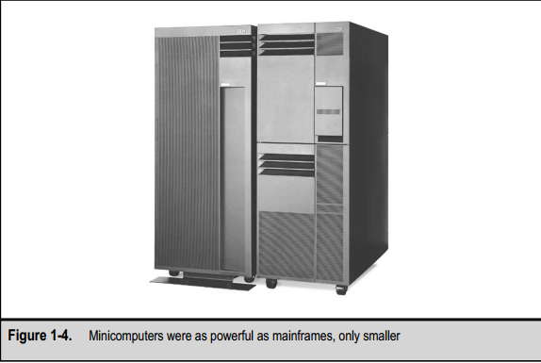

**1.5 Other Computers**

You may have heard of a couple of other computer classifications: the supercomputer and the embedded computer. A *supercomputer,* like the one pictured in Figure 1-5, is an extremely powerful computer used mostly in research and space, military, and governmental applications. A supercomputer, which can cost tens of millions of dollars, contains the equivalent of thousands of personal computers that share in the processing load to solve very large and complex problems in hours or days instead of weeks, months, oryears. A supercomputer is the largest and most powerful computer, sometimes equaling the power of several mainframes combined. For example, the Massachusetts Institute of Technology (MIT) is using a supercomputer to calculate the value of the mathematic value *pi* to over a million decimal places, so far. Although it is the stuff dreams are made of, a supercomputer is way beyond consideration as a personal computer.

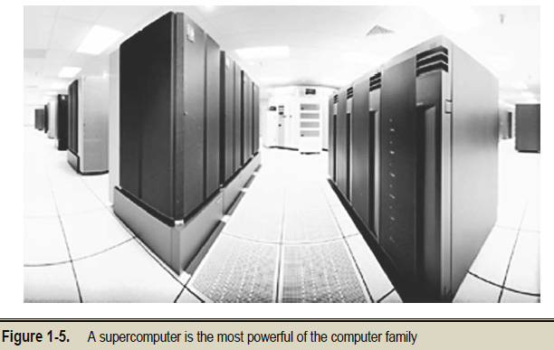

* 1. **AN OVERVIEW OF SYSTEMS AND COMPONENTS**

Okay, let’s take a quick tour of a typical personal computer’s hardware. Study Figure 1.6 and take note of each of the items in the illustration.

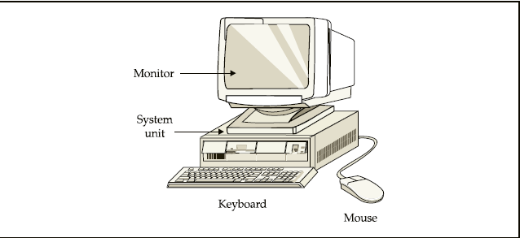

Fig 1.6 the hardware of atypical pc.

The items in Figure 1.6 correspond to the following:

* The monitor, which is also called the display, the visual display unit (VDU), or the screen
* The keyboard
* The system unit, which contains the motherboard, disk drives, expansion cards, and input/output ports
* The mouse

The desktop computer in Figure 1.6, where the monitor sits on top of the system unit is a very common configuration for personal computers. Other popular PC configurations are the tower and minitower computers, in which the system units sits on the floor or other surface and the monitor sits separately on a desktop or wherever. Figure 1.7 shows a tower-style computer. Computers also come in small packages. The notebook computer (see Figure 1.8)has made power-computing very portable. The pocket-sized palmtop computer, such as the Casio Cassiopia (Figure 1.9) and the personal digital assistant (PDA), such as the3Com Palm Pilot or the Mindspring Visor (see Figure 1.10), has the ability to perform many personal productivity applications.

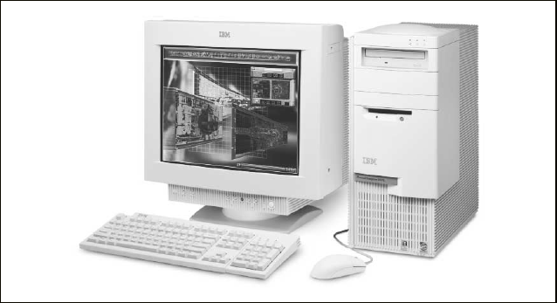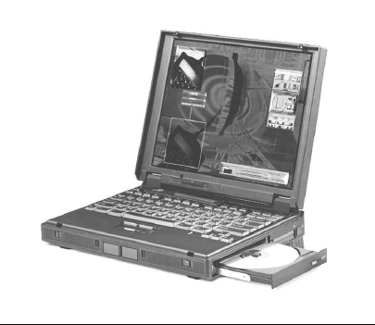

Fig 1.7 A Tower type desktop. Fig 1.8 A Notebook PC

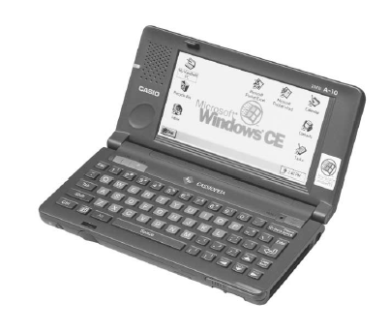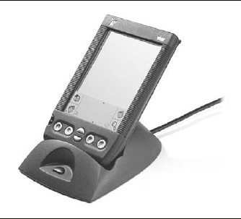

FIG 1.9 A Palmtop computer. Fig 1.10 A PDA

Regardless of the size of the package, personal computers all have the same six groups of hardware components:

* Input devices
* Output (display) devices
* Processor/motherboard
* Adapters/Peripherals
* Storage devices
* Power supply

**CHAPTER 2**

**2.0 COMPUTER HARDWARE COMPONENT**

**2.1 Input Devices**

Computers process data into information; simulate an action or animation; and, among other actions, replicate hand motions to draw an image. What each of these actions or processes has in common is that each requires some form of interaction with an operator. At least so far, the operator is generally human and the human needs to provide instructions, data, or other stimuli (called inputs) to the computer so it can do its thing. To facilitate this interaction, the computer must provide devices that the operator can use to give it its inputs. Reasonably enough, these devices are called *input devices*. Over the years, the most common input device has been the keyboard. However, in the past few years, it has been a dead heat between the keyboard and mouse (see Figure 1.11) because virtually every computer sold has both devices. Newer hybrid devices now even combine the two, replacing the mouse with a touchpad built right into the keyboard. This hybrid style is very common on notebook computers, as shown in Figure 1-12. See Chapter 18 for more information on keyboards and other input devices.

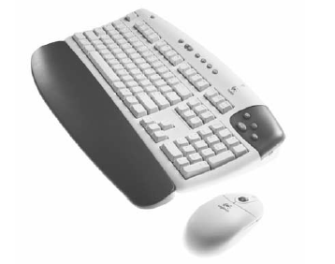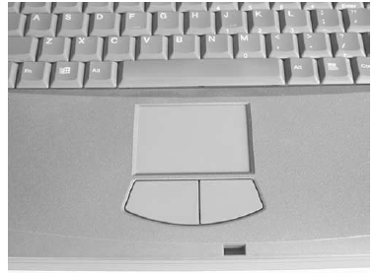

Fig. 1.11 Keyboard and mouse. Fig. 1.12 keyboard and touchpad

Following are some of the important input devices which are used in a computer −

* Keyboard
* Mouse
* Joy Stick
* Light pen
* Track Ball
* Scanner
* Graphic Tablet
* Microphone
* Magnetic Ink Card Reader(MICR)
* Optical Character Reader(OCR)
* Bar Code Reader
* Optical Mark Reader(OMR)

1. **Keyboard:** Keyboard is the most common and very popular input device which helps to input data to the computer. The layout of the keyboard is like that of traditional typewriter, although there are some additional keys provided for performing additional functions.

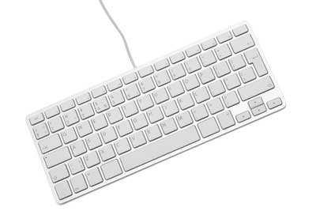

Keyboards are of two sizes 84 keys or 101/102 keys, but now keyboards with 104 keys or 108 keys are also available for Windows and Internet.

The keys on the keyboard are as follows:

|  |  |  |
| --- | --- | --- |
|  |  | **Keys & Description** |
|  |  | * **Typing Keys**: These keys include the letter keys (A-Z) and digit keys (09) which generally give the same layout as that of typewriters. |
|  |  | * **Numeric Keypad:** It is used to enter the numeric data or cursor movement. Generally, it consists of a set of 17 keys that are laid out in the same configuration used by most adding machines and calculators. |
|  |  | * **Function Keys**: The twelve function keys are present on the keyboard which are arranged in a row at the top of the keyboard. Each function key has a unique meaning and is used for some specific purpose. |
|  |  | * **Control keys**: These keys provide cursor and screen control. It includes four directional arrow keys. Control keys also include Home, End, Insert, Delete, Page Up, Page Down, Control(Ctrl), Alternate(Alt), Escape(Esc). |
|  |  | * **Special Purpose Keys**: Keyboard also contains some special purpose keys such as Enter, Shift, Caps Lock, Num Lock, Space bar, Tab, and Print Screen. |

1. **Mouse:** Mouse is the most popular pointing device. It is a very famous cursor-control device having a small palm size box with a round ball at its base, which senses the movement of the mouse and sends corresponding signals to the CPU when the mouse buttons are pressed.

Generally, it has two buttons called the left and the right button and a wheel is present between the buttons. A mouse can be used to control the position of the cursor on the screen, but it cannot be used to enter text into the computer.

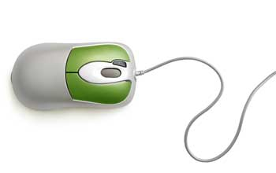

**Advantages of mouse**

* Easy to use
* Not very expensive
* Moves the cursor faster than the arrow keys of the keyboard.

1. **Joystick:** Joystick is also a pointing device, which is used to move the cursor position on a monitor screen. It is a stick having a spherical ball at its both lower and upper ends. The lower spherical ball moves in a socket. The joystick can be moved in all four directions.

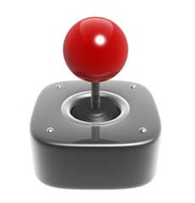

The function of the joystick is similar to that of a mouse. It is mainly used in Computer Aided Designing (CAD) and playing computer games.

1. **Light Pen:** Light pen is a pointing device similar to a pen. It is used to select a displayed menu item or draw pictures on the monitor screen. It consists of a photocell and an optical system placed in a small tube.



When the tip of a light pen is moved over the monitor screen and the pen button is pressed, its photocell sensing element detects the screen location and sends the corresponding signal to the CPU.

1. **Track Ball:** Track ball is an input device that is mostly used in notebook or laptop computer, instead of a mouse. This is a ball which is half inserted and by moving fingers on the ball, the pointer can be moved.

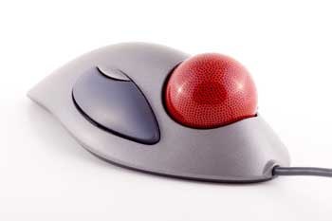

Since the whole device is not moved, a track ball requires less space than a mouse. A track ball comes in various shapes like a ball, a button, or a square.

1. **Scanner:** Scanner is an input device, which works more like a photocopy machine. It is used when some information is available on paper and it is to be transferred to the hard disk of the computer for further manipulation.

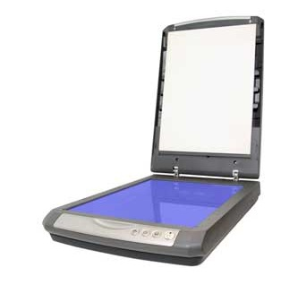

Scanner captures images from the source which are then converted into a digital form that can be stored on the disk. These images can be edited before they are printed.

1. **Digitizer:** Digitizer is an input device which converts analog information into digital form. Digitizer can convert a signal from the television or camera into a series of numbers that could be stored in a computer. They can be used by the computer to create a picture of whatever the camera had been pointed at.

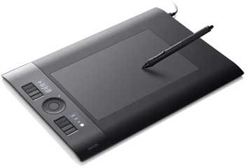

Digitizer is also known as Tablet or Graphics Tablet as it converts graphics and pictorial data into binary inputs. A graphic tablet as digitizer is used for fine works of drawing and image manipulation applications.

1. **Microphone:** Microphone is an input device to input sound that is then stored in a digital form.

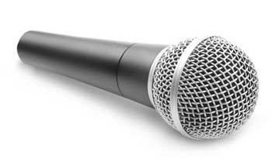

The microphone is used for various applications such as adding sound to a multimedia presentation or for mixing music.

1. **Magnetic Ink Card Reader (MICR):** MICR input device is generally used in banks as there are large number of cheques to be processed every day. The bank's code number and cheque number are printed on the cheques with a special type of ink that contains particles of magnetic material that are machine readable.

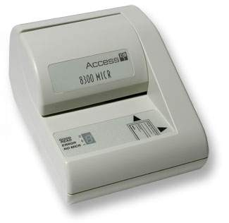

This reading process is called Magnetic Ink Character Recognition (MICR). The main advantages of MICR is that it is fast and less error prone.

1. **Optical Character Reader (OCR):** OCR is an input device used to read a printed text.

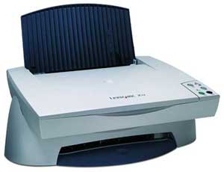

OCR scans the text optically, character by character, converts them into a machine readable code, and stores the text on the system memory.

1. **Bar Code Readers:** Bar Code Reader is a device used for reading bar coded data (data in the form of light and dark lines). Bar coded data is generally used in labelling goods, numbering the books, etc. It may be a handheld scanner or may be embedded in a stationary scanner.

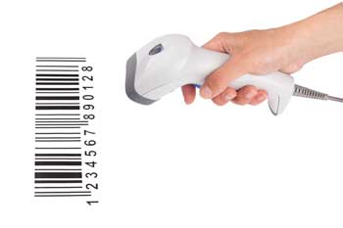

Bar Code Reader scans a bar code image, converts it into an alphanumeric value, which is then fed to the computer that the bar code reader is connected to.

1. **Optical Mark Reader (OMR):** OMR is a special type of optical scanner used to recognize the type of mark made by pen or pencil. It is used where one out of a few alternatives is to be selected and marked.

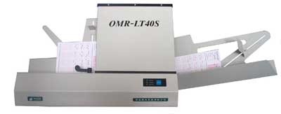

It is specially used for checking the answer sheets of examinations having multiple choice questions.

**2.2 Output Devices**

The output devices of any computer are linked to the senses of its human operator. If you haven’t made this connection before, give it some thought. The computer must communicate with its operator through one of their senses, most likely sight and sound. These two human senses allow the operator to see and hear the outputs produced by the computer. The other human senses could be used, but at least so far the computer has not had much success with using the operator’s senses of touch, taste, and smell. (You know systems that produce real-time smells can’t be too far into the future, and there are already printers that can produce their output in Braille for sight-impaired users.)

Following are some of the important output devices used in a computer.

* Monitors
* Printer and Graphic Plotter
* Sounds devices

## Monitors:

Monitors, commonly called as **Visual Display Unit** (VDU), are the main output device of a computer. It forms images from tiny dots, called pixels that are arranged in a rectangular form. The sharpness of the image depends upon the number of pixels.

There are two kinds of viewing screen used for monitors.

* Cathode-Ray Tube (CRT)
* Flat-Panel Display

### Cathode-Ray Tube (CRT) Monitor

The CRT display is made up of small picture elements called pixels. The smaller the pixels, the better the image clarity or resolution. It takes more than one illuminated pixel to form a whole character, such as the letter ‘e’ in the word help.

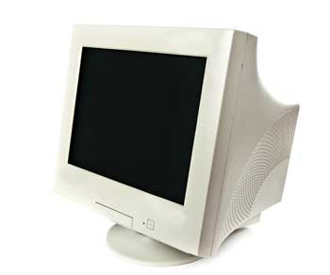

A finite number of characters can be displayed on a screen at once. The screen can be divided into a series of character boxes - fixed location on the screen where a standard character can be placed. Most screens are capable of displaying 80 characters of data horizontally and 25 lines vertically.

There are some disadvantages of CRT −

* Large in Size
* High power consumption

### Flat-Panel Display Monitor

The flat-panel display refers to a class of video devices that have reduced volume, weight and power requirement in comparison to the CRT. You can hang them on walls or wear them on your wrists. Current uses of flat-panel displays include calculators, video games, monitors, laptop computer, and graphics display.

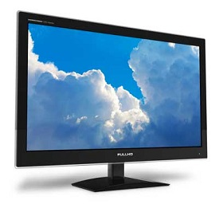

The flat-panel display is divided into two categories −

* **Emissive Displays** − Emissive displays are devices that convert electrical energy into light. For example, plasma panel and LED (Light-Emitting Diodes).
* **Non-Emissive Displays** − Non-emissive displays use optical effects to convert sunlight or light from some other source into graphics patterns. For example, LCD (Liquid-Crystal Device).

## Printers

Printer is an output device, which is used to print information on paper.

There are two types of printers −

* Impact Printers
* Non-Impact Printers

### a) Impact Printers

Impact printers print the characters by striking them on the ribbon, which is then pressed on the paper.

Characteristics of Impact Printers are the following −

* Very low consumable costs
* Very noisy
* Useful for bulk printing due to low cost
* There is physical contact with the paper to produce an image

These printers are of two types −

* Character printers
* Line printers

**Character Printers**

Character printers are the printers which print one character at a time.

These are further divided into two types:

* Dot Matrix Printer(DMP)
* Daisy Wheel

**Dot Matrix Printer**

In the market, one of the most popular printers is Dot Matrix Printer. These printers are popular because of their ease of printing and economical price. Each character printed is in the form of pattern of dots and head consists of a Matrix of Pins of size (5*7, 7*9, 9*7 or 9*9) which come out to form a character which is why it is called Dot Matrix Printer.

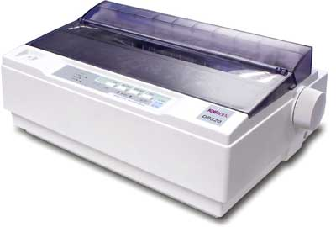

**Advantages**

* Inexpensive
* Widely Used
* Other language characters can be printed

**Disadvantages**

* Slow Speed
* Poor Quality

**Daisy Wheel**

Head is lying on a wheel and pins corresponding to characters are like petals of Daisy (flower) which is why it is called Daisy Wheel Printer. These printers are generally used for word-processing in offices that require a few letters to be sent here and there with very nice quality.

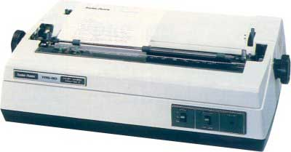

**Advantages**

* More reliable than DMP
* Better quality
* Fonts of character can be easily changed

**Disadvantages**

* Slower than DMP
* Noisy
* More expensive than DMP

**Line Printers**

Line printers are the printers which print one line at a time.

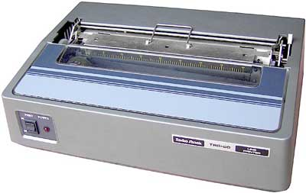

These are of two types −

* Drum Printer
* Chain Printer

**Drum Printer**

This printer is like a drum in shape hence it is called drum printer. The surface of the drum is divided into a number of tracks. Total tracks are equal to the size of the paper, i.e. for a paper width of 132 characters, drum will have 132 tracks. A character set is embossed on the track. Different character sets available in the market are 48 character set, 64 and 96 characters set. One rotation of drum prints one line. Drum printers are fast in speed and can print 300 to 2000 lines per minute.

**Advantages**

* Very high speed

**Disadvantages**

* Very expensive
* Characters fonts cannot be changed

**Chain Printer**

In this printer, a chain of character sets is used, hence it is called Chain Printer. A standard character set may have 48, 64, or 96 characters.

**Advantages**

* Character fonts can easily be changed.
* Different languages can be used with the same printer.

**Disadvantages**

* Noisy

### b) Non-impact Printers

Non-impact printers print the characters without using the ribbon. These printers print a complete page at a time, thus they are also called as Page Printers.

These printers are of two types −

* Laser Printers
* Inkjet Printers

**Characteristics of Non-impact Printers**

* Faster than impact printers
* They are not noisy
* High quality
* Supports many fonts and different character size

**Laser Printers**

These are non-impact page printers. They use laser lights to produce the dots needed to form the characters to be printed on a page.

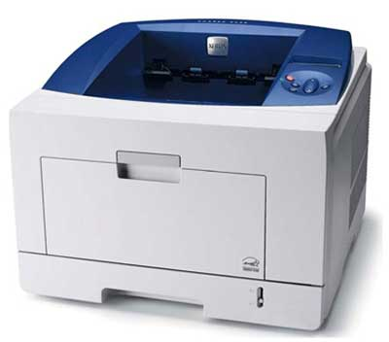

**Advantages**

* Very high speed
* Very high quality output
* Good graphics quality
* Supports many fonts and different character size

**Disadvantages**

* Expensive
* Cannot be used to produce multiple copies of a document in a single printing

**Inkjet Printers**

Inkjet printers are non-impact character printers based on a relatively new technology. They print characters by spraying small drops of ink onto paper. Inkjet printers produce high quality output with presentable features.

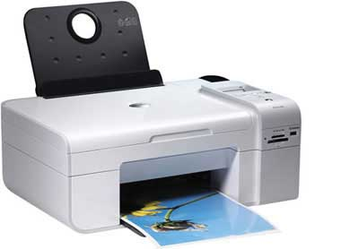

They make less noise because no hammering is done and these have many styles of printing modes available. Color printing is also possible. Some models of Inkjet printers can produce multiple copies of printing also.

**Advantages**

* High quality printing
* More reliable

**Disadvantages**

* Expensive as the cost per page is high
* Slow as compared to laser printer

1. **Sound Devices**

The other common output from a personal computer is sound. Whether it is as simple as the beep codes produced through the system speaker when the computer is started up or the near-high fidelity sounds produced from a CD-ROM or DVD, digital systems and sound are a match made in audio heaven.

**2.3 MEMORY**

A memory is just like a human brain. It is used to store data and instructions. Computer memory is the storage space in the computer, where data is to be processed and instructions required for processing are stored. The memory is divided into large number of small parts called cells. Each location or cell has a unique address, which varies from zero to memory size minus one. For example, if the computer has 64k words, then this memory unit has 64 * 1024 = 65536 memory locations. The address of these locations varies from 0 to 65535.

Memory is classified into three types

* Cache Memory
* Primary Memory/Main Memory
* Secondary Memory

## Cache Memory

Cache memory is a very high speed semiconductor memory which can speed up the CPU. It acts as a buffer between the CPU and the main memory. It is used to hold those parts of data and program which are most frequently used by the CPU. The parts of data and programs are transferred from the disk to cache memory by the operating system, from where the CPU can access them.

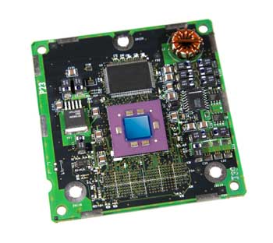

### Advantages

The advantages of cache memory are as follows −

* Cache memory is faster than main memory.
* It consumes less access time as compared to main memory.
* It stores the program that can be executed within a short period of time.
* It stores data for temporary use.

### Disadvantages

The disadvantages of cache memory are as follows −

* Cache memory has limited capacity.
* It is very expensive.

## Primary Memory (Main Memory)

Primary memory holds only those data and instructions on which the computer is currently working. It has a limited capacity and data is lost when power is switched off. It is generally made up of semiconductor device. These memories are not as fast as registers. The data and instruction required to be processed resides in the main memory. It is divided into two subcategories RAM and ROM.

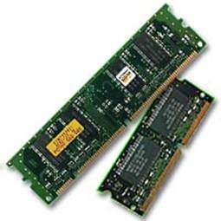

### Characteristics of Main Memory

* These are semiconductor memories.
* It is known as the main memory.
* Usually volatile memory.
* Data is lost in case power is switched off.
* It is the working memory of the computer.
* Faster than secondary memories.
* A computer cannot run without the primary memory.

RAM (Random Access Memory) is the internal memory of the CPU for storing data, program, and program result. It is a read/write memory which stores data until the machine is working. As soon as the machine is switched off, data is erased.



Access time in RAM is independent of the address, that is, each storage location inside the memory is as easy to reach as other locations and takes the same amount of time. Data in the RAM can be accessed randomly but it is very expensive.

RAM is volatile, i.e. data stored in it is lost when we switch off the computer or if there is a power failure. Hence, a backup Uninterruptible Power System (UPS) is often used with computers. RAM is small, both in terms of its physical size and in the amount of data it can hold.

RAM is of two types −

* Static RAM (SRAM)
* Dynamic RAM (DRAM)

## Static RAM (SRAM)

The word **static** indicates that the memory retains its contents as long as power is being supplied. However, data is lost when the power gets down due to volatile nature. SRAM chips use a matrix of 6-transistors and no capacitors. Transistors do not require power to prevent leakage, so SRAM need not be refreshed on a regular basis.

There is extra space in the matrix, hence SRAM uses more chips than DRAM for the same amount of storage space, making the manufacturing costs higher. SRAM is thus used as cache memory and has very fast access.

### Characteristic of Static RAM

* Long life
* No need to refresh
* Faster
* Used as cache memory
* Large size
* Expensive
* High power consumption

## Dynamic RAM (DRAM)

DRAM, unlike SRAM, must be continually **refreshed** in order to maintain the data. This is done by placing the memory on a refresh circuit that rewrites the data several hundred times per second. DRAM is used for most system memory as it is cheap and small. All DRAMs are made up of memory cells, which are composed of one capacitor and one transistor.

### Characteristics of Dynamic RAM

* Short data lifetime
* Needs to be refreshed continuously
* Slower as compared to SRAM
* Used as RAM
* Smaller in size
* Less expensive
* Less power consumption

ROM stands for **Read Only Memory**. The memory from which we can only read but cannot write on it. This type of memory is non-volatile. The information is stored permanently in such memories during manufacture. A ROM stores such instructions that are required to start a computer. This operation is referred to as **bootstrap**. ROM chips are not only used in the computer but also in other electronic items like washing machine and microwave oven.

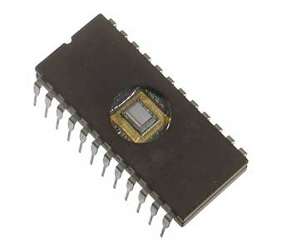

Let us now discuss the various types of ROMs and their characteristics.

## MROM (Masked ROM)

The very first ROMs were hard-wired devices that contained a pre-programmed set of data or instructions. These kind of ROMs are known as masked ROMs, which are inexpensive.

## PROM (Programmable Read Only Memory)

PROM is read-only memory that can be modified only once by a user. The user buys a blank PROM and enters the desired contents using a PROM program. Inside the PROM chip, there are small fuses which are burnt open during programming. It can be programmed only once and is not erasable.

## EPROM (Erasable and Programmable Read Only Memory)

EPROM can be erased by exposing it to ultra-violet light for a duration of up to 40 minutes. Usually, an EPROM eraser achieves this function. During programming, an electrical charge is trapped in an insulated gate region. The charge is retained for more than 10 years because the charge has no leakage path. For erasing this charge, ultra-violet light is passed through a quartz crystal window (lid). This exposure to ultra-violet light dissipates the charge. During normal use, the quartz lid is sealed with a sticker.

## EEPROM (Electrically Erasable and Programmable Read Only Memory)

EEPROM is programmed and erased electrically. It can be erased and reprogrammed about ten thousand times. Both erasing and programming take about 4 to 10 ms (millisecond). In EEPROM, any location can be selectively erased and programmed. EEPROMs can be erased one byte at a time, rather than erasing the entire chip. Hence, the process of reprogramming is flexible but slow.

## Advantages of ROM

The advantages of ROM are as follows −

* Non-volatile in nature
* Cannot be accidentally changed
* Cheaper than RAMs
* Easy to test
* More reliable than RAMs
* Static and do not require refreshing
* Contents are always known and can be verified

## Secondary Memory (auxiliary memory)

This type of memory is also known as external memory or non-volatile. It is slower than the main memory. These are used for storing data/information permanently. CPU directly does not access these memories, instead they are accessed via input-output routines. The contents of secondary memories are first transferred to the main memory, and then the CPU can access it. For example, disk, CD-ROM, DVD, etc.

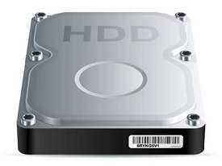

### Characteristics of Secondary Memory

* These are magnetic and optical memories.
* It is known as the backup memory.
* It is a non-volatile memory.
* Data is permanently stored even if power is switched off.
* It is used for storage of data in a computer.
* Computer may run without the secondary memory.
* Slower than primary memories.

**2.3 THE MOTHERBOARD**

The motherboard serves as a single platform to connect all of the parts of a computer together. It connects the CPU, memory, hard drives, optical drives, video card, sound card, and other ports and expansion cards directly or via cables. It can be considered as the backbone of a computer.

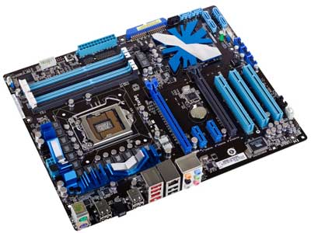

## Features of Motherboard

A motherboard comes with following features −

* Motherboard varies greatly in supporting various types of components.
* Motherboard supports a single type of CPU and few types of memories.
* Video cards, hard disks, sound cards have to be compatible with the motherboard to function properly.
* Motherboards, cases, and power supplies must be compatible to work properly together.

## Description of Motherboard

The motherboard is mounted inside the case and is securely attached via small screws through pre-drilled holes. Motherboard contains ports to connect all of the internal components. It provides a single socket for CPU, whereas for memory, normally one or more slots are available. Motherboards provide ports to attach the floppy drive, hard drive, and optical drives via ribbon cables. Motherboard carries fans and a special port designed for power supply.

There is a peripheral card slot in front of the motherboard using which video cards, sound cards, and other expansion cards can be connected to the motherboard.

On the left side, motherboards carry a number of ports to connect the monitor, printer, mouse, keyboard, speaker, and network cables. Motherboards also provide USB ports, which allow compatible devices to be connected in plug-in/plug-out fashion. For example, pen drive, digital cameras, etc.

The motherboard serves as a single platform to connect all of the parts of a computer together. It connects the CPU, memory, hard drives, optical drives, video card, sound card, and other ports and expansion cards directly or via cables. It can be considered as the backbone of a computer.



## Features of Motherboard

A motherboard comes with following features −

* Motherboard varies greatly in supporting various types of components.
* Motherboard supports a single type of CPU and few types of memories.
* Video cards, hard disks, sound cards have to be compatible with the motherboard to function properly.
* Motherboards, cases, and power supplies must be compatible to work properly together.

## Description of Motherboard

The motherboard is mounted inside the case and is securely attached via small screws through pre-drilled holes. Motherboard contains ports to connect all of the internal components. It provides a single socket for CPU, whereas for memory, normally one or more slots are available. Motherboards provide ports to attach the floppy drive, hard drive, and optical drives via ribbon cables. Motherboard carries fans and a special port designed for power supply.

There is a peripheral card slot in front of the motherboard using which video cards, sound cards, and other expansion cards can be connected to the motherboard.

On the left side, motherboards carry a number of ports to connect the monitor, printer, mouse, keyboard, speaker, and network cables. Motherboards also provide USB ports, which allow compatible devices to be connected in plug-in/plug-out fashion. For example, pen drive, digital cameras, etc.

**2.4 PORTS**

A port is a physical docking point using which an external device can be connected to the computer. It can also be programmatic docking point through which information flows from a program to the computer or over the Internet.

## Characteristics of Ports

A port has the following characteristics −

* External devices are connected to a computer using cables and ports.
* Ports are slots on the motherboard into which a cable of external device is plugged in.
* Examples of external devices attached via ports are the mouse, keyboard, monitor, microphone, speakers, etc.

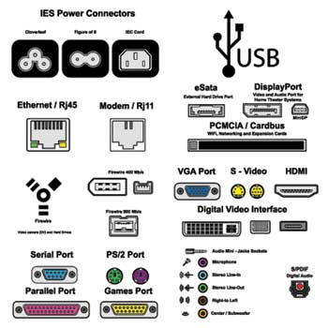

Let us now discuss a few important types of ports −

## Serial Port

* Used for external modems and older computer mouse
* Two versions: 9 pin, 25 pin model
* Data travels at 115 kilobits per second

## Parallel Port

* Used for scanners and printers
* Also called printer port
* 25 pin model
* IEEE 1284-compliant Centronics port

## PS/2 Port

* Used for old computer keyboard and mouse
* Also called mouse port
* Most of the old computers provide two PS/2 port, each for the mouse and keyboard
* IEEE 1284-compliant Centronics port

## Universal Serial Bus (or USB) Port

* It can connect all kinds of external USB devices such as external hard disk, printer, scanner, mouse, keyboard, etc.
* It was introduced in 1997.
* Most of the computers provide two USB ports as minimum.
* Data travels at 12 megabits per seconds.
* USB compliant devices can get power from a USB port.

## VGA Port

* Connects monitor to a computer's video card.
* It has 15 holes.
* Similar to the serial port connector. However, serial port connector has pins, VGA port has holes.

## Power Connector

* Three-pronged plug.
* Connects to the computer's power cable that plugs into a power bar or wall socket.

## Firewire Port

* Transfers large amount of data at very fast speed.
* Connects camcorders and video equipment to the computer.
* Data travels at 400 to 800 megabits per seconds.
* Invented by Apple.
* It has three variants: 4-Pin FireWire 400 connector, 6-Pin FireWire 400 connector, and 9-Pin FireWire 800 connector.

## Modem Port

* Connects a PC's modem to the telephone network.

## Ethernet Port

* Connects to a network and high speed Internet.
* Connects the network cable to a computer.
* This port resides on an Ethernet Card.
* Data travels at 10 megabits to 1000 megabits per seconds depending upon the network bandwidth.

## Game Port

* Connect a joystick to a PC
* Now replaced by USB

## Digital Video Interface, DVI port

* Connects Flat panel LCD monitor to the computer's high-end video graphic cards.
* Very popular among video card manufacturers.

## Sockets

* Sockets connect the microphone and speakers to the sound card of the computer.

CHAPTER THREE

* 1. **THE MICROPROCESSOR**

The microprocessor is a multifunction integrated circuit that is, in essence, the computer. The processor, which is also called the central processing unit (CPU), is made up of several parts. These parts work together to carry out the instructions and actions that translate to a word processing system or a game on your PC. The primary parts of the CPU, as illustrated in Figure 3.0, are as follows:

_ **Control Unit (CU)** At the risk of being obvious, the control unit *controls* the functions of the CPU. It is kind of like the manager who coordinates the activities between the different parts of a factory. It tells the other parts of the CPU how to operate, what data to use, and where to put the results.

_ **Protection Test Unit (PTU)** This part of the CPU works with the control unit to monitor whether or not functions are carried out correctly. It is like the quality control department of the CPU. If it detects something is not done properly, it generates an error signal.

_ **Arithmetic and Logic Unit (ALU)** The ALU performs all of the calculations and comparative logic functions for the CPU, including all add, subtract ,divide, multiply, equal to, greater than, less than, and other arithmetic and logic operations.

_ **Floating Point Unit (FPU)** The FPU goes by several other names, including the math coprocessor, the numerical processing unit (NPU), and the numerical data processor (NDP). It handles all floating point operations for the ALU and CU. *Floating point* operations involve arithmetic on numbers with decimal

Places and high math operations like trigonometry and logarithms.

_ **Memory Management Unit (MMU)** The MMU handles the addressing and cataloging of where data is stored in system memory. Whenever the CPU needs something from memory, it requests it from the MMU. The MMU manages memory segmentation and paging allocations and translates all logical addressing into physical addressing.

_ **Bus Interface Unit (BIU)** The BIU supervises the transfer of data over the bus system between the other components of the computer and the CPU. It also serves as the interface point for the CPU and its external bus, as well as handling all data transfers out of the control unit.

_ **The Prefetch Unit** This unit preloads the instruction registers of the CPU with instructions from memory whenever the BIU is idle. This allows the CPU to look ahead at future instructions. The prefetch unit does not analyze instructions, so on occasion it may bring in an unnecessary instruction because it assumes that the instructions will be carried out one after the other without branching or jumps.

_ **Decode Unit** Many instructions are actually combinations of simpler instructions. The decode unit does just about what its name suggests. It decodes incoming instructions to their simplest form. While the prefetch unit retrieving more instructions, this unit decodes them to get them ready for the control unit.

_ **Registers** Built into the CPU are a number of holding areas and buffers that are used to temporarily hold the data, addresses, and instructions being passed around between the CPU’s components. These are the registers.

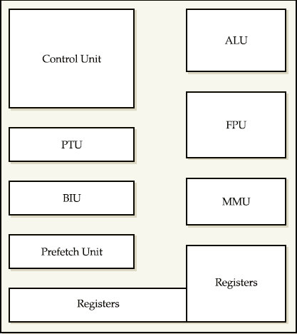

Fig.3.1 the component of the cpu

3.1 Major Components of the CPU

In the CPU, the primary components are the [ALU](https://www.computerhope.com/jargon/a/alu.htm) (Arithmetic Logic Unit) that performs mathematical, logical, and decision operations and the [CU](https://www.computerhope.com/jargon/c/contunit.htm) (Control Unit) that directs all of the processors operations and memory that stores data and instruction to be executed.

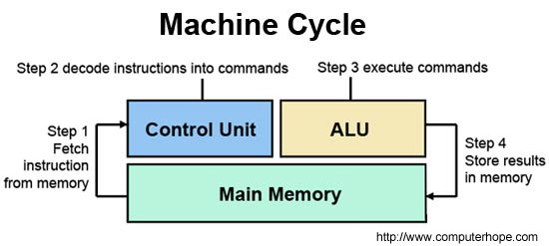

**3.2 CPU’s Bus System**

The *bus*, as it relates to the pathways on the computer and in the processor, carries the various Signals, addresses, and data (remember, *data* is plural) that are transferred around the computer between its components. Although quite dissimilar, it can be related to the routes of your local transit company in many ways. On the computer, a bus structure is a group of electronic transmission lines that connect the various components of the CPU, motherboard, and expansion cards to each other. Bus structures have different sizes, ranging from 16 to 64 bits on modern micro processors, and their size determines the amount of data that can be transmitted. Obviously, a 64-bit bus carries more data than a 16-bit bus. Within the computer, there are several bus structures. The most important of these are as follows:

_ **Data bus** Carries information to and from the CPU.

_ **Address bus** carries the address from where data is to be read to where data is to be written.

_ **Control bus** Carries the signals used by the CPU and the other components of the computer to communicate with each other, including when data is ready to be read, when another device wishes to use the bus, and the typeof operation to be performed (read, write, interrupt).

**3.3 Packaging**

When you look at a microprocessor, like the Pentium, it is the packaging that you see rather than the microprocessor itself that is packaged inside the ceramic or plastic outer shell. he outer covering of the processor, protects the core that contains the microchip and the wiring that connects the chip to the processor’s pin grid array (PGA).

The pins of the PGA are inserted into the mounting socket or the slot edge connectors. Older packaging designs were often in ceramic, which has excellent heat resistance and dissipation properties, but most of today’s processors are mounted in plastic-encased SECC (single-edge contact cartridge) cards. SECC packaging features built-in mountings for a heat sink and a fan, easy upgrading, and high-speed access by the motherboard to the CPU.

**3.4 Cooling the Processor**

Before the Intel 486, microprocessors were cooled largely by the airflow inside the case created by the system fan. This was called *radiant cooling*. Any heat radiated by the processor was cooled by air being sucked into the system case by the fan in the power supply. Beginning with the 486, processors were cooled with a *heat sink* or *processor cooling fan* or both, attached directly to the surface of the processor. In addition, the system fan was reversed to extract the heated air from inside the computer case and force it out. Commonly, the processor is not the only high-heat device inside the computer case. Other high-performance devices, such as accelerated video cards and high-speed hard

Disk drives, can also produce significant heat. Computer case designs should provide for enough ventilation to allow cool air to be drawn in and hot air to be expelled. Other wise,the computer’s lifespan will be dramatically shorter.

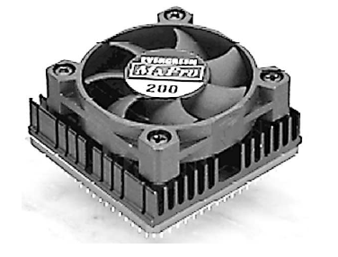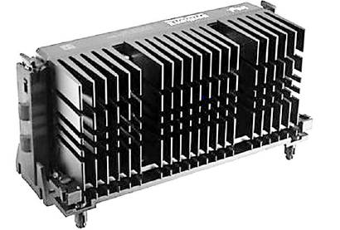

Fig. 3.4(a) cooling fan Fig. 3.4(b) Heat sink

**3.4 Sockets and Slots**

Microprocessors are attached to the motherboard of the computer. There are two general types of mountings used to connect the processor onto the motherboard sockets and slots. Some processors are available in only one mounting type; others, such as the Intel Celerons, are available with both types of mountings. Which type is used is largely a matter of preference on the part of the processor manufacturer. The two types look very different, but functionally their differences are small.

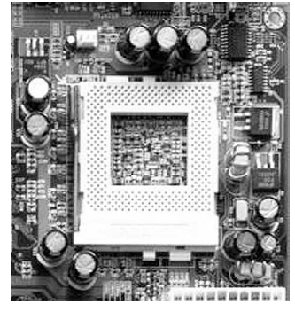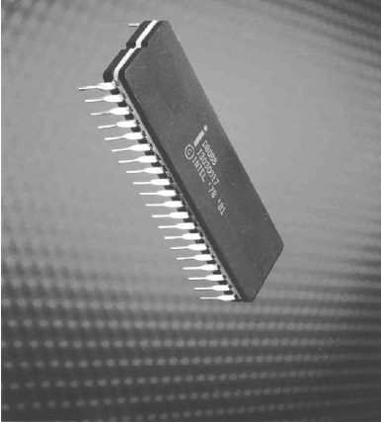

Fig. 3.4a socket type microprocessor

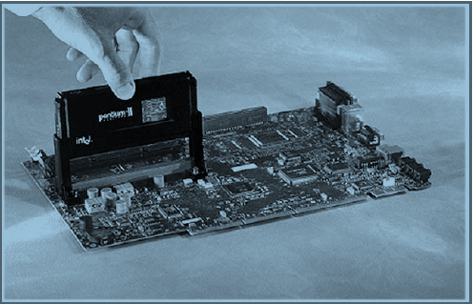

Fig. 3.4b slot type microprocessor.

CHAPTER F0UR

5.0 MOTHERBOARDS

The motherboard is easily the most important part of the computer. Although there

are a number of components that a PC cannot function without, it’s the motherboard

that ties them all together and turns them into a personal computer.

The *motherboard*, or main board, of a PC is a large printed circuit board that is home to

many of the most essential parts of the computer, including the microprocessor, chipset,

cache, memory sockets, expansion bus, parallel and serial ports, mouse and keyboard

connectors, and IDE, EIDE, or SCSI controllers, among other components of the PC. The

motherboard binds the PC’s operational components together. Even devices like printers,

hard disks, CD-ROMs, and the like, either connect to or are controlled by the devices or

controllers on the motherboard.

There is a wide variety of shapes, sizes, and types of motherboards available. There is

at least one motherboard design from at least one manufacturer to fit just about every PC

still running. Manufacturers attempt to set their motherboards apart from the others and

to increase their value by incorporating more or fewer controllers, expansion buses,

processor sockets, external connectors, and memory slots.

**5.1 MOTHERBOARD DESIGNS**

Not all motherboards are created equal. To begin with, two different design approaches

are used for PC main boards: the motherboard style and the backplane style.

**5.1.1 Motherboards**

A *motherboard* (also known as a main board, system board, or a planar) aggregates all of

the PC’s primary system components on a single printed circuit board (PCB). In the

motherboard’s single board design, all of the PC’s electronic circuitry that provides the

conduit through which all operations flow is located on the motherboard.

**5.1.2 Backplanes**

Backplane main boards are common in large PC network servers and on other computers on which the processor is upgraded frequently. In its basic form, a *backplane* main board contains very little in the way of intelligence and storage capabilities. It is merely a receptacle board into which processor cards,

memory cards, and other component boards are inserted to add capability to a PC.

**5.2 MOTHERBOARD FORM FACTORS**

Essentially, a *form factor* defines a motherboard’s size, shape, and how it is mounted to the case.

However, form factors now include the size, shape, and function of the system case; the type, placement, and size of the power supply; the system’s power requirements; the location and type of external connectors, and the case’s airflow and cooling systems. Table 5.2 lists the more common PC form factors used in PCs.

In case you are wondering why Apple Computer motherboards aren’t listed, Apple was never an *open architecture*, which means that its designs weren’t shared with other manufacturers. Apple motherboards only worked in Apple computers and each successive model of the Apple II and Macintosh computers had its own distinctive motherboard. Apple computers may have had form factors, but they were not industry standards.

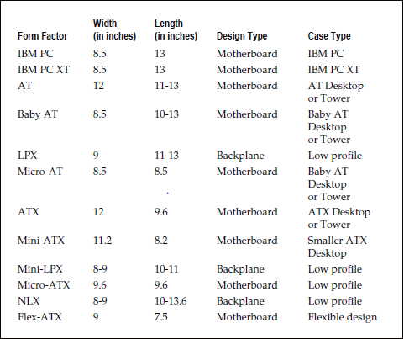

Table. Motherboard form factor

**5.3 THE COMPONENTS OF THE MOTHERBOARD**

The motherboard is the foundation on which a PC is built. It provides the interconnecting circuitry through which the primary components of the motherboard receive their power and pass control signals, data, addresses, and instructions to each other. In short, with a microprocessor installed on the motherboard, it is essentially the computer. Figure 5.3 shows where the major components are found on a typical motherboard. Figure 5.3 identifies each of the following major parts of the motherboard:

* **CPU slot and socket** The CPU mounts to the motherboard through either a slot or socket mounting.
* **Chipset** Many of the circuit and CPU level functions are contained in the chipset.
* **Memory sockets** Depending on the age of the PC, its memory is mounted on the motherboard as individual memory chips that fit into separate DIP (dual inline packaging) sockets or as memory modules, such as a SIMM (single inline memory module) or a DIMM (dual inline memory module), that snap into edge connector mountings.
* **BIOS ROM** The BIOS (Basic Input/Output System) is stored as firmware on a read-only memory (ROM) chip. The BIOS is used to start the PC up when the power is turned on and provides a link for the CPU to the PC’s peripheral devices.
* **CMOS battery** The configuration of a PC at the systems level is stored in a type of memory, CMOS (Complementary Metal Oxide Semiconductor), that requires very little power to hold its contents. The CMOS battery supplies a steady power source to store the system configuration for use during the PC’s boot sequence.
* **Power connector** A connection must be made to the power supply so that power is available to the circuitry on the motherboard. Motherboards use different voltages of power for different components on the board.
* **I/O connectors** The motherboard includes a variety of external I/O connectors that allow external devices to communicate with the CPU.
* **Expansion slots** External peripherals and internal devices are interconnected into the motherboard and CPU through the expansion bus. The motherboard features a variety of expansion slots that usually include three or more of the different expansion buses available.

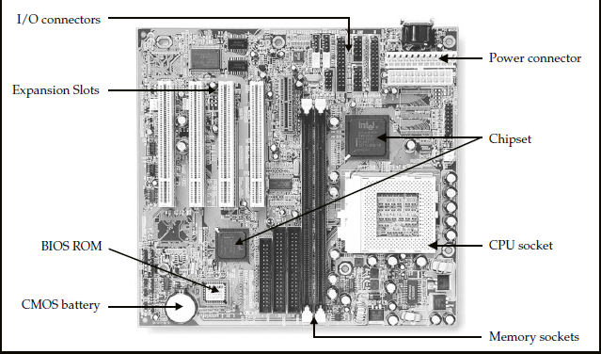

Fig. 5.3 Motherboard and its components

**UPGRADING A MOTHERBOARD**

If your old PC isn’t quite as fast or as powerful as your friends’ computers and you’d really like to move up, you have two choices: buy a whole new computer or upgrade the motherboard (and possibly some of your PC’s peripheral devices). Depending on the upgrade you do, in general, upgrading your motherboard and CPU will cost you a whole lot less than a brand new computer. The cost may not be the deciding factor though; you may just want to upgrade for the fun and satisfaction of doing it. Here is a list of the criteria you should consider when evaluating your PC and deciding how to upgrade it:

* **The CPU: E**nsure that the processor you wish to move to is within the specification of the motherboard.
* **Sockets and slots** The specifications for the CPU you wish to move up to should specify its socket or slot requirements. Trust me, you won’t confuse a socket for a slot mounting.
* **Bus speed** The bus speed supported on a motherboard must be matched to the processor, most of the other motherboard components, and especially the cache memory, must also be matched to the maximum allowable motherboard speed.
* **Memory modules** : Before you start cramming memory modules into open slots, verify the total amount of memory supported by your motherboard and the type of memory supported by the processor and chipset.
* **Expansion bus** Consider your current expansion cards and what controllers or adapters may be built into your new motherboard. You will need to match your expansion card needs to the number of bus slots available on the motherboard.
* **BIOS** The motherboard should use an industry-standard BIOS such as those from AMI, Phoenix, or Award. Preferably, the BIOS chip should be the flash ROM (EEPROM) type.
* **Chipset** There are reasons to upgrade the chipset on a PC, but the rule is that the chipset must be matched to the processor and the motherboard. The chipset enables and supports such motherboard functions as parity checking, USB ports, multiple CPUs, and other performance issues.

OTHER FACTORS INCLUDE:

* **Form factor**, **Built-in controllers and interfaces and** **Documentation.**

**CHAPTER FIVE**

**CHIPSETS AND CONTROLLERS**

The most important component of a PC is the motherboard. Among the components on the motherboard contributing to its importance are the chipset and its associated controllers. This group of devices provides much of a PC’s functionality and its ability to accept, display, and move data. The logic circuits of the chipset and controllers give the motherboard its intelligence and its ability to function.

The chipset and controllers also control the movement of data on the system buses so that data and instructions can move about the PC, between the CPU, cache memory, and peripherals. The system chipset plays a major role in a PC’s function, feature set, and speed. Unless data and instructions are able to flow between one component of the PC and another, there isn’t much point to even powering up the PC.

The chipset controls the bits (data, instructions, and control signals) that flow between

the CPU, system memory, and over the motherboard’s bus. The chipset also manages data transfers between the CPU, memory, and peripheral devices and provides support for the expansion bus and any power management features of the system.

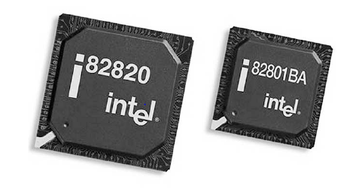

FIG 5.0 The Intel 820E chipset. Image courtesy of Intel Corporation

**Socket Type**

The socket type used to mount the CPU on the motherboard is the most common grouping for chipsets. You will find Socket 7 chipsets in one group, Socket 8 chipsets in another, Socket 1 and 370 chipsets in a third, and SlotA chipsets in another. There are chipsets that do not conform to this grouping technique, such as AMD’s K7 chipset and others that generally form their own separate groupings.

**North Bridge and South Bridge**

Another characteristic that sets one chipset apart from another is whether it has one, two, or more chips in the set. The two-chip chipset, which contains what is called the north bridge and the south bridge, is the most common, but some manufacturers, produce mostly single chipsets today. Other chipsets have as many as six chips in the set. Figure 5-2 illustrates the relationship of these two elements.

The north bridge is the major bus circuitry that provides support and control for the main memory, cache memory, and the PCI bus controllers. The north bridge is typically a single chip (usually the larger of a two or more chipset), but it can be more than one chip.

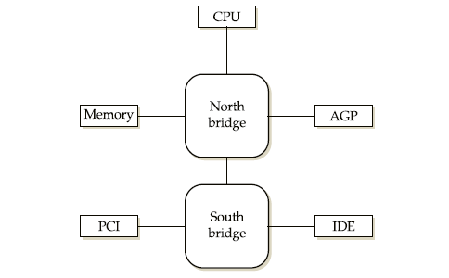

FIG 5.1 The relationship of a chipset’s north bridge and south bridge

The south bridge includes the controllers for the peripheral devices and any controllers not essential to the PC’s basic functions, such as the EIDE (Enhanced Integrated Device Electronics) controller and the serial port controllers.

**CONTROLLER CHIPS**

Generally, a chipset does not incorporate all of the controllers used to direct the actions of every peripheral device on the PC. In addition to the chipset, there are at least two, and possibly more, controllers mounted directly on the motherboard. In most cases, the motherboard will have at minimum a keyboard controller and an I/O controller (a.k.a. the Super I/O controller). Some expansion cards, such as video adapters, sound cards, network interface cards (NICs), and SCSI (Small Computer System Interface) adapters, have built-in controller chips. Individual controller chips come in all sizes and shapes, as illustrated in Figure 5-3.

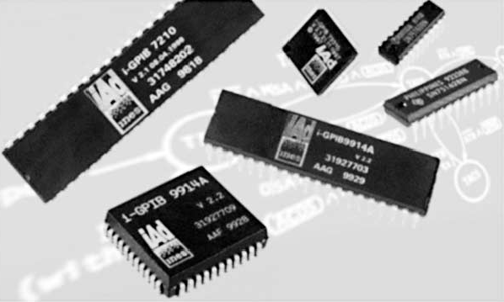

FIG 5.3 Controller chips control individual I/O or devices.

A controller chip controls the transfer of data to and from a peripheral device, such as a disk drive, the monitor, the keyboard, or a printer. All of these devices depend on a device controller to interact with the CPU and the rest of the PC.

**Bus Architectures**

The bus architecture of the PC is made up of the wires, connectors, and devices that move

data and instructions around the PC. The bus structure, which got its name from the fact that it resembles the lines on a city bus map, connects the controllers on the motherboard, the CPU, memory, I/O ports, and expansion slots. The PC’s bus architecture becomes very important when you add additional device controller cards to the motherboard’s expansion slots. Most of the latest motherboard designs include expansion slots for multiple bus structures, including PCI (Peripheral Component Interconnect) and AT Bus, and possibly SCSI. Each of the bus architectures supported on a motherboard requires a bus controller chip.